./

GENESIS - Learning Outcome & Mini-project Summary Report



|  |  |  |  |  |  |
| --- | --- | --- | --- | --- | --- |
| **Ver. Rel. No.** | **Release Date** | **Prepared. By** | **Reviewed By** | **To be Approved** | **Remarks/Revision Details** |
|  |  |  |  |  |  |
|  |  |  |  |  |  |
|  |  |  |  |  |  |
|  |  |  |  |  |  |
|  |  |  |  |  |  |

**Details**

Contents

Contents 3

Table of Figures 4

Table of Tables 4

Miniproject -1 [Team: 99003731, 99003733, 99003734, 99003735] 5

Module 5

Topic and Subtopics 5

Objectives & Requirements 5

Design 9

Test Plan 15

Implementation Summary 18

Video Summary 18

Git Link 18

Git Dashboard 19

Summary 19

Individual Contribution & Highlights 26

Summary 26

Challenges faced and how were they overcome 27

Future Scope 27

Miniproject -2 [Team: 99003731, 99003768, 99003786] 28

Module 28

Topic and Subtopics 28

Objectives & Requirements 28

Design 30

Test Plan 32

Implementation Summary 33

Individual Contribution & Highlights 34

Summary 35

Challenges faced and how were they overcome 35

Miniproject -3 [Individual] 36

Module 36

Topic and Subtopics 36

Objectives & Requirements 37

Design 38

Test Plan 40

Implementation Summary 43

Video Summary 43

Git Link 43

Git Dashboard 44

Summary 44

Challenges faced and how were they overcome 44

Future Scope 44

Miniproject -4 [Individual] 45

Module 45

Topic and Subtopics 45

Objectives & Requirements 45

Design 45

Test Plan 45

Implementation Summary 45

Video Summary 45

Git Link 45

Git Dashboard 45

Summary 45

Individual Contribution & Highlights 46

Summary 46

Challenges faced and how were they overcome 46

Future Scope (If applicable) 46

Table of Figures

Figure 1. Class-Diagram 9

Figure 2. Use-Case Diagram 10

Figure 3.Object-Diagram – (Basic Arithmetic, Matrix, Combinatorics) 11

Figure 4.Class-Diagram – (Physics) 11

Figure 5. Class Diagram – (Financial, Profit loss) 12

Figure 6.Use-Case Diagram 13

Figure 7.Sequential Diagram 13

Figure 8.Workflow-Badges 18

Figure 9.High-Level Design(Activity-Diagram) -Embedded C 29

Figure 10.Low-Level Design (Use-Case Diagram) Embedded C 30

Figure 11.Implemented Circuit of Door Latch-Detection System 33

Figure 12.Implemented Circuit of Parking Assistance System 34

Figure 13.High-Level Design (Activity Diagram) Python 38

Figure 14. Low-Level Design (Activity Diagram) Python 39

Table of Tables

Table 1. High-Level Requirements(SDLC) 6

Table 2.Low-Level Requirements(SDLC) 8

Table 3. High-Level Testing(SDLC) 14

Table 4. Low -Level Testing(SDLC) 17

Table 5. High Level Requirements (Embedded C) 28

Table 6. Low-Level Requirements (Embedded C) 28

Table 7. High-Level Testing (Embedded C) 31

Table 8. Low -Level Testing (Embedded C) 32

Table 9.High-Level Requirements (Python) 36

Table 10.Low-Level Requirements (Python) 37

Table 11.High-Level Testing (Python) 40

Table 12.Low-Level Testing (Python) 41

# Miniproject -1 [Team: 99003731, 99003733, 99003734, 99003735]

## Module

“SDLC (System Development Life-Cycle)”

### Topic and Subtopics

#### Core -Topics

* V-Model

##### Sub-Topic

* C Programming
* MakeFile
* Unit Testing
* Version Control (via GitHub)
* Agile-Methodology

##### Sub-Topic

* Theme
* Epic
* User-Story

All these Core-topics and sub-topics are implemented through V-Model Technique.

## Objectives & Requirements

#### Objective

To Design a calculator with certain features according to the specific requirements by following V-Model flow.

#### Requirements

##### High Level Requirements

|  |  |  |  |
| --- | --- | --- | --- |
| **ID** | **Requirements** | **Description** | **Status** |
| HLRAM001 | Physics Calculation | Several Physics functions are implemented | Implemented, Tested |
| HLRAM002 | Profit and Loss Calculation | Day to Day use of profit and loss function make it more useful | Implemented, Tested |
| HLRSS003 | Basic Arithmetic Calculations | Very basic operations like +, -, /, * | Implemented, Tested |
| HLRSS004 | Matrix operation | Several Matrix functions | Implemented, Not Tested |
| HLRSS005 | Combinatorics Calculation | Permutation and Combination | Implemented, Tested |
| HLRSA006 | Special math functions | functions like logarithm, exponential, square root | Implemented, Tested |
| HLRSA007 | financial calculation | Simple interest, Compound interest, EMI calculation | Implemented, Tested |
| HLRPK008 | Mensuration | Area, Volume | Implemented, Tested |
| HLRPK009 | AP, GP, Sum | Mean | Implemented, Tested |
| HLRAM001 | Physics Calculation | Several Physics functions are implemented | Implemented, Tested |
| HLRAM002 | Profit and Loss Calculation | Day to Day use of profit and loss function make it more useful | Implemented, Tested |

Table 1. High-Level Requirements(SDLC)

##### Low Level Requirements

|  |  |  |  |
| --- | --- | --- | --- |
| ID | Requirements | Description | Status |
| HLRAM001 – LR1 | Acceleration Calculation | By taking v, u, t as an input | Implemented |
| HLRAM001 – LR2 | Capacitive reactance Calculation | By taking C, f as an input | Implemented |
| HLRAM001 – LR3 | Circular velocity Calculation | By taking r, t as an input | Implemented |
| HLRAM001 – LR4 | Coulombs law Calculation | Making 'K' constant as well as taking q1, q2 and distance between them as an input | Implemented |
| HLRAM001 – LR5 | Projectile motion Calculation | Initial Velocity, Angle and g as an input | Implemented |
| HLRAM002 – LR1 | Profit calculation | Taking SP and CP as user input and Check SP > CP | Implemented |
| HLRAM002 – LR2 | Loss calculation | Taking SP and CP as user input and Check CP > SP | Implemented |
| HLRAM002 – LR3 | Discount calculation | Taking input as CP and enter the percentage of discount as an input | Implemented |
| HLRSS003 - LR1 | Addition | Taking two numbers as input | Implemented |
| HLRSS003 - LR2 | Subtraction | Taking two numbers as input | Implemented |
| HLRSS003 - LR3 | Multiply | Taking two numbers as input | Implemented |
| HLRSS003 - LR4 | Divide | Taking two numbers as input | Implemented |
| HLRSS004 - LR1 | Matrix Addition | Taking two matrices as input and their dimension | Implemented |
| HLRSS004 - LR2 | Matrix Subtraction | Taking two matrices as input and their dimension | Implemented |
| HLRSS004 - LR3 | Matrix Multiplication | Taking two matrices as input and their dimension | Implemented |
| HLRSS004 - LR4 | Matrix Determinant | Taking a matrix as input and its dimension | Implemented |
| HLRSS004 - LR5 | Matrix Row or Column sum | Taking a matrix as input and its dimension with specific row or column | Implemented |
| HLRSS005 - LR1 | Permutation | Taking input for total no. of objects and for no. of permutations | Implemented |
| HLRSS006 - LR2 | Combination | Taking input for total no. of objects and for no. of permutations | Implemented |
| HLRPK007 - LR1 | Area | Initiating the required input | Implemented |
| HLRPK007 - LR2 | Volume | Initiating the required input | Implemented |
| HLRPK008 - LR1 | Mean | Initiating the required input | Implemented |
| HLRSA009 - LR1 | logarithm | Taking one number as input with base as 10 | Implemented |
| HLRSA009 - LR2 | exponential | Taking one number as input | Implemented |
| HLRSA009 - LR3 | Square root | Taking one number as input | Implemented |
| HLRSA0010 - LR1 | Simple interest calculator | Taking Principal amount, Time-period, Rate of interest as input | Implemented |
| HLRSA0010 - LR2 | Compound interest calculator | Taking Principal amount, Time-period, Rate of interest as input | Implemented |
| HLRSA0010 - LR3 | EMI Calculator | Taking Principal amount, Time-period, Rate of interest as input | Implemented |

Table 2.Low-Level Requirements(SDLC)

## Design

#### System Level Design (High-Level)

##### Structural

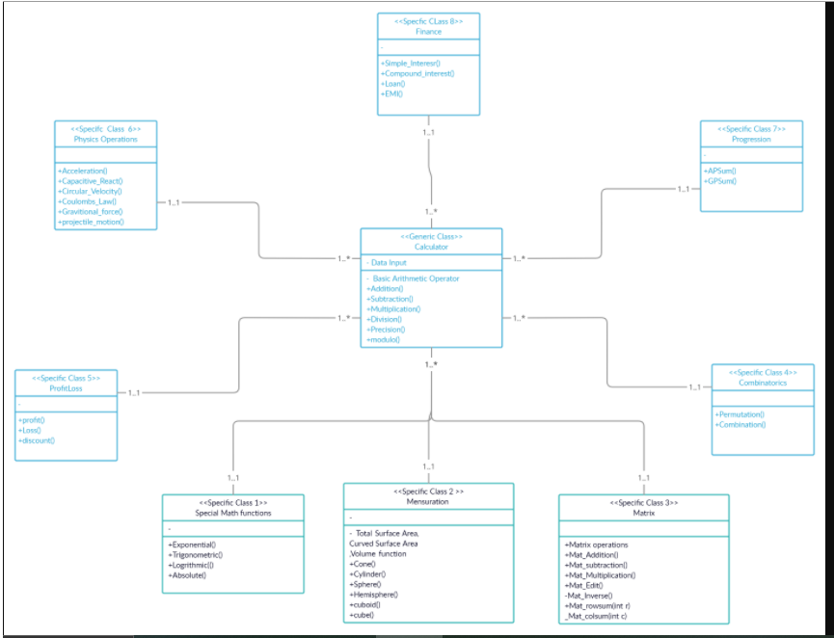

Figure 1. Class-Diagram

##### Behavioral

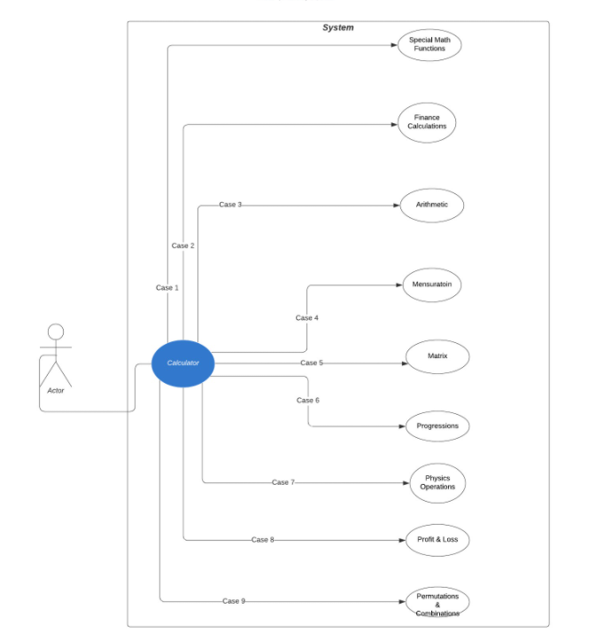

Figure 2. Use-Case Diagram

#### Sub-System Level (Low-Level Design)

##### Structural

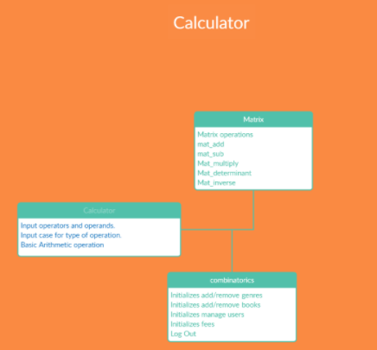

Figure 3.Object-Diagram – (Basic Arithmetic, Matrix, Combinatorics)

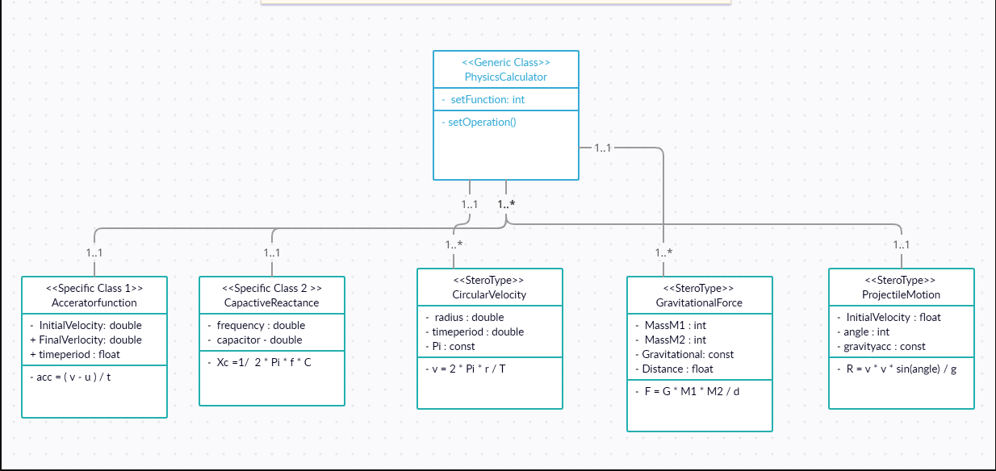

Figure 4.Class-Diagram – (Physics)

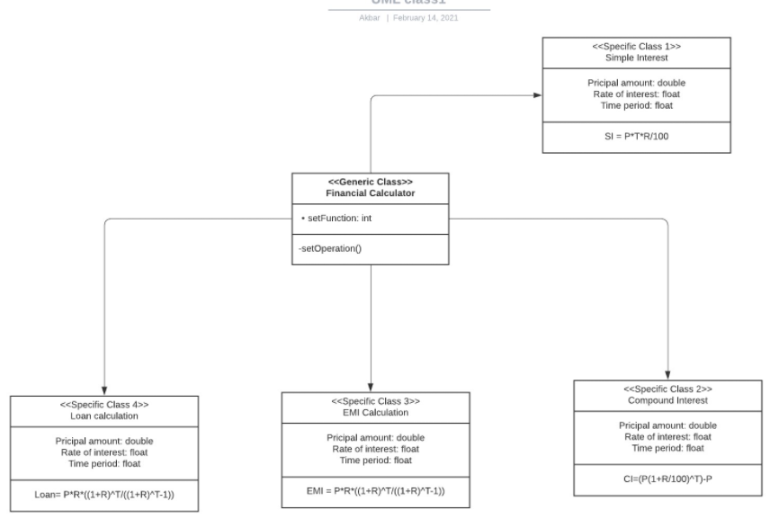

Figure 5. Class Diagram – (Financial, Profit loss)

##### Behavioral

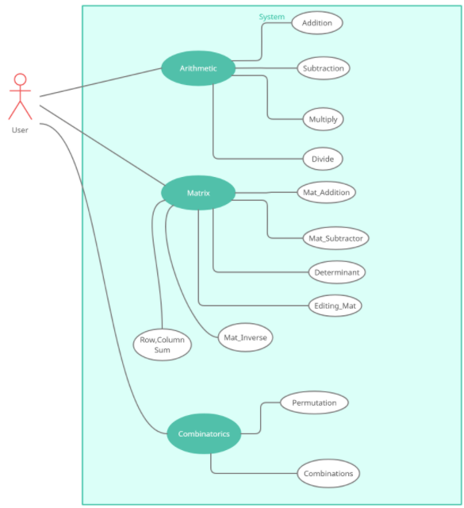

Figure 6.Use-Case Diagram

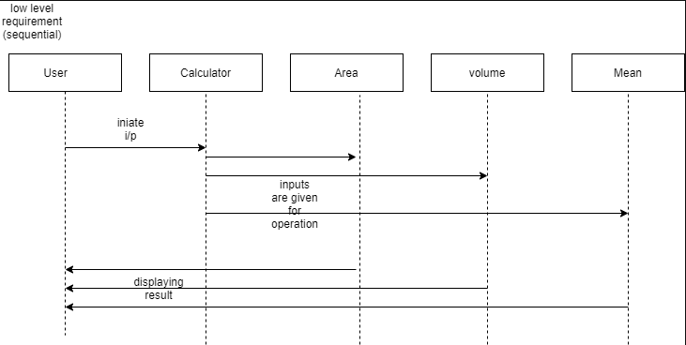

Figure 7.Sequential Diagram

## Test Plan

#### Integration Level Testing

|  |  |  |  |  |  |
| --- | --- | --- | --- | --- | --- |
| **Test ID** | **Description** | **Expected Input** | **Expected Output** | **Actual Out** | **Type of Test** |
| H_01 | mode switch working for special operations | mode==1 | shows mode menu | shows mode menu | Requirement based |
| H_02 | mode switch working | mode==2 | Error | Error | Scenario based |

Table 3. High-Level Testing(SDLC)

#### Unit-Level Testing

|  |  |  |  |  |  |
| --- | --- | --- | --- | --- | --- |
| **Test ID** | **Description** | **Expected Input** | **Expected Output** | **Actual Out** | **Type of Test** |
| L_0111 | Adding two numbers | num1= 30, num2=20 | result=50 | result=50 | Requirement based |
| L_0121 | Subtracting two numbers | num1= 0, num2=3 | result=-3 | result=-3 | Requirement based |
| L_0131 | Multiplying two numbers | num1= 1, num2=0 | result=0 | result=0 | Requirement based |
| L_0141 | Dividing two numbers | num1= 27, num2=9 | result=3 | result=3 | Requirement based |
| L_0211 | Adding two negative numbers | num1=-750, num2=-7500 | result=-8250 | result=-8250 | Scenario based |
| L_0212 | Adding one negative number and one positive number | num1=10, num2=-20 | result=-10 | result=-10 | Scenario based |
| L_0213 | Adding one positive number and one negative number | num1=-98, num2=20 | result=-78 | result=-78 | Scenario based |
| L_0221 | Subtracting two positive numbers | num1=13, num2=4 | result=9 | result=9 | Scenario based |
| L_0222 | Subtracting positive number from a negative number | num1=-45, num2=6 | result=-51 | result=-51 | Scenario based |
| L_0223 | Subtracting two negative numbers | num1=-7985, num2=-7745 | result=-240 | result=-240 | Scenario based |
| L_0231 | Multiplying one positive number with one negative number | num1=-20, num2=3 | result=-60 | result=-60 | Scenario based |
| L_0232 | Multiplying one negative number with one positive number | num1=8745, num2=-83 | result=-725835 | result=-725835 | Scenario based |
| L_0233 | Multiplying two negative numbers | num1=-99, num2=-999 | result=98901 | result=98901 | Scenario based |
| L_0241 | Dividing by zero | num1=1, num2=0 | result=-1(for error) | result=-1 | Scenario based |
| L_0242 | Dividing two negative number | num1=-135, num2=-3 | result=45 | result=45 | Scenario based |
| L_0243 | Dividing negative number by positive number | num1=-28, num2=14 | result=-2 | result=-2 | Scenario based |
| L_0244 | Dividing positive number by negative number | num1=96, num2=-12 | result=-8 | result=-8 | Scenario based |
| L_0311 | Multiplying two 8 digit numbers | num1=100000000, num2=99999999 | result=-1 | result=-1(for Error) | Boundary based |
| L_0411 | Calculating Permutations | n=5, r=1 | permutations=5 | permutations=5 | Requirement based |
| L_0421 | Calculating Combinations | n=2, r=1 | combinations=2 | combinations=2 | Requirement based |
| L_0511 | If number of required permutations is greater than total number of objects | n=4, r=6 | permutations=-1(for Error) | permutations=-1 | Scenario based |
| L_0512 | If entered inputs are negative for permutation function | n=-3, r=1 | combinations=-1(for Error) | combinations=-1 | Scenario based |
| L_0521 | If number of required combinations is greater than total number of objects | n=4, r=10 | combinations=-1(for Error) | combinations=-1 | Scenario based |
| L_0522 | If entered inputs are negative for combination function | n=4, r=10 | combinations=-1(for Error) | combinations=-1 | Scenario based |
| L_0611 | Calculating Acceleration | v=10, u=5, t=5 | accefunc = 1 | accefunc = 1 | Scenario based |
| L_0621 | Finding capacitive Reactance | f=100, C= 5 | react= 0.00031830 | react = 0.00031830 | Requirement based |
| L_0631 | Finding Circular Velocity | r = 100, t = 2 | velocity= 314.159265 | velocity = 314.159265 | Requirement based |
| L_0641 | Finding Circular Velocity | M1 = 1000, M2 = 1000, D = 2 | Force= 0.000016675 | Force = 0.000016675 | Requirement based |
| L_0651 | Finding Projectile motion | V = 25, angle=15 | Range = 31.887755 | Range = 31.887755 | Requirement based |
| L_0711 | Calculating profit and loss | sp = 120, cp=12 | res = 108 | res = 108 | Requirement based |
| L_0721 | Calculating Discount | mp = 100, d=15 | disc_price = 85 | disc_price = 85 | Requirement based |
| L_0811 | For Matrix Determinant | [10 ,20 ,30; 5, 6, 7; 1, 0, 0] | Determinant=80 | Determinant=80 | Requirement based |
| L_0821 | Matrix Addition | MAT1= [9 ,30 ,10; -2 ,8 ,10 ;10,-5 ,50 ], MAT2=[10 ,9 ,-5 ;8 ,2 ,0 ;30 ,4 ,10] | ADD_MAT= [19 ,39 ,5 ;6 ,10 ,10 ;40 ,-1, 60] | ADD_MAT= [19 ,39 ,5 ;6 ,10 ,10 ;40 ,-1, 60] | Requirement based |
| L_0831 | Matrix Subtraction | MAT1= [9 ,3 ,10; -2 ,8 ,10 ;10, -5 ,50], MAT2= [1 ,9 ,-5 ;8 ,2 ,0 ;30 ,4 ,10] | SUB_MAT= [8,-6 ,15 ;-10 ,6 ,10 ;-20 ,-9 , 40] | SUB_MAT= [8,-6 ,15 ;-10 ,6 ,10 ;-20 ,-9 , 40] | Requirement based |
| L_0911 | Matrix addition or subtraction | am=2, an=3, bm=2, bn=2 | Error | Error | Scenario based |
| L_0912 | Matrix multiply | am=1, an=3, bm=2, bn=1 | Error | Error | Scenario based |
| L_1011 | Calculate simple interest | principal amount=10000, Time-period=2, rate of interest=8 | result=1600 | result=1600 | Requirement based |
| L_1021 | Calculate compound interest | principal amount=10000, Time-period=2, rate of interest=8 | result=1728 | result=1728 | Requirement based |
| L_1031 | Calculate EMI amount | principal amount=10000, Time-period=2, rate of interest=8 | result=10855 | result=10855 | Requirement based |
| L_1041 | Calculate Loan amount | principal amount=10000, Time-period=2, rate of interest=8 | result=10855 | result=10855 | Requirement based |
| L_1051 | Calculate simple interest | principal amount=10000, Time-period=3, rate of interest=6 | result=1800 | result=2000 | Scenario based |
| L_1061 | Calculate compound interest | principal amount=30000, Time-period=4, rate of interest=9 | result=12942 | result=14000 | Scenario based |
| L_1071 | Calculate EMI amount | principal amount=25000, Time-period=2, rate of interest=8 | result=1131 | result=1500 | Scenario based |
| L_1081 | Calculate Loan amount | principal amount=100000, Time-period=4, rate of interest=7 | result=2395 | result=2000 | Scenario based |
| L_1111 | Calculate exponent | value=3 | result=20.08 | result=20.08 | Requirement based |
| L_1121 | Calculate logarithm | value=10 | result=1 | result=1 | Requirement based |
| L_1131 | Calculate square root | value=144 | result=12 | result=12 | Requirement based |
| L_1211 | Calculate exponent | value=5 | result=148.41 | result=100 | Scenario based |
| L_1221 | Calculate logarithm | value=-10 | result=Error | result=1 | Scenario based |

Table 4. Low -Level Testing(SDLC)

## Implementation Summary

Implementation has all the source files, header files, test files for different features of the calculator such as Basic Arithmetic, Combinatorics, Matrix, Profitloss, Trigonometry, financial, special math functions, physics and mensuration.

Here, inc folder holds all header files with “. h” extension which contains prototype of all functions, structure definition, macro definition and definition of all the enumerators.

The src folder holds all source files with “.c” extension which has definition of all functions whose prototype is defined in header file.

The test folder holds the test_main.c file for cumulative testing of the source codes on based on requirement, scenario and boundary.

Other than these folders outside there is a predefined unity folder which holds prototypes and definition of the standard unity test case functions.

Also, there is Makefile which builds, debugs using valgrind, checks static and dynamic code quality, performs overall unit testing for all the codes together with the execution of single commands based on different defined targets.

There is project_main.c using which you can run the calculator designed by us in a menu-driven approach.

Mandatory: To add the GitHub user - **stepin654321** as a contributor to the repo”

### Video Summary

“Please upload a short video on the repo for the walkthrough of the project (Team/Individual) less than 7min and less than 30MB File Size. Start is the Standard opening slide with title of Miniproject + Team members followed by the walkthrough ”

### Git Link

<https://github.com/99003733/SDLC_N2_Calculator.git>

### Git Dashboard

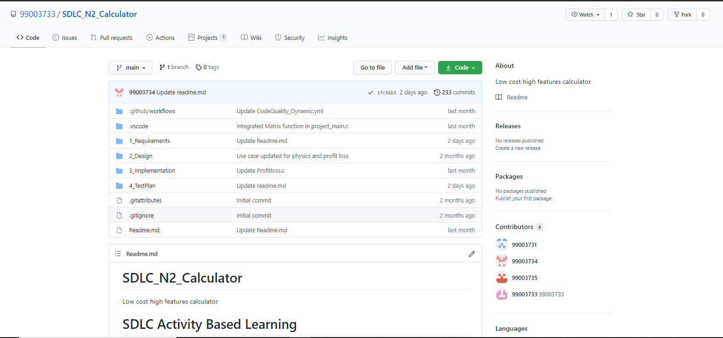

#### Badges

Figure 8.Workflow-Badges

### Summary

In this project, we mainly-focused on how to design a calculator which is bit different and cost-effective as compared to other calculators present in the market.

So, for this we first analyzed all the other calculators from low-end feature low cost calculator to high-end feature high-cost calculator and prepared a list of features to include in our modified cost-effective more featured calculator.

Features included in the calculator are basic arithmetic operations (addition, subtraction, multiplication, division), Physics operations (Acceleration, capacitive reactance, circular velocity, Coulomb’s Law, Gravitational force, projectile motion), Matrix Operations (Matrix Addition, Matrix Subtraction, Matrix Multiplication, Matrix row sum , Matrix Column Sum, Matrix Determinant), Combinatorics (Permutations and Combinations), Mensuration (Area and Volumes ), Profit and Loss operations (Profit, Loss, Discount) , Finance operations (Simple Interest, Compound Interest, EMI calculations) , AP,GP sum (AP sum , GP sum) and Special Math Functions (Exponential, Trigonometric, Logarithm).

This calculator is implemented through C programming. This calculator will be mainly used by the school, college students, scientists, businessman, engineers for various purpose. Also, this calculator will be cost effective and if implemented over hardware it cost around 1000 – 1500 INR.

#### Git inspector summary

#### Build

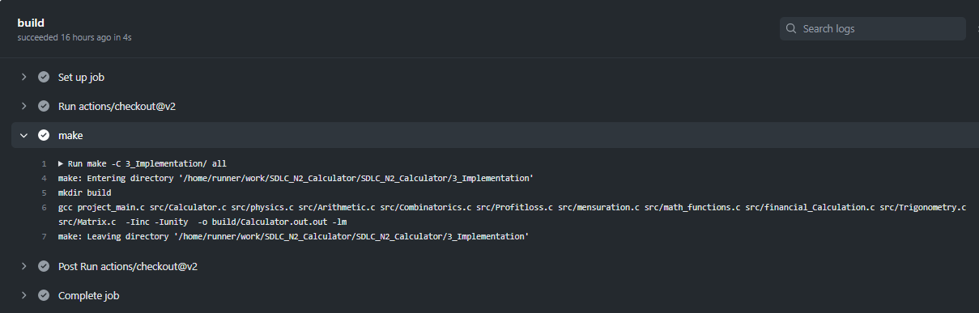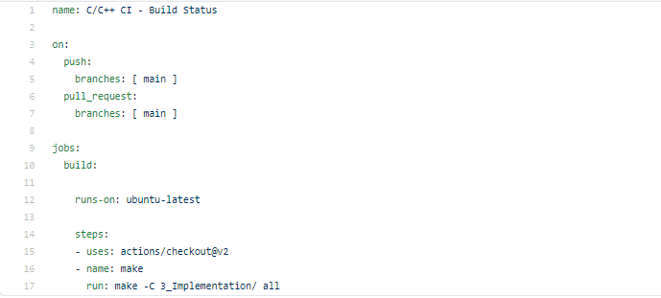

#### Code quality and Issues or Bug Tracking

##### Static Code Quality

##### Dynamic Code Quality

#### Unit Testing

## Individual Contribution & Highlights

#### Individual Contribution

My Contribution to this project in designing features like basic arithmetic functions, combinatorics feature and matrix operation feature. I have implemented all the three features and tested ‘arithmetic and combinatorics using unity.

Also, I have performed the research analysis of different calculators present in market based on features and cost.

I have integrated the code of the whole team in project_main.c and Calculator.c which is present inside src folder. Also, I have integrated the whole test code.

I have modified Makefile so that program should be able to build as well as it is able to perform unity based unit testing.

#### Highlights

### Summary

This project was our first step to work in coordination as a team while working towards our development of our individual skills.

Also, we’re unorganized at the beginning but after planning through V-Model we’re able to analyze and design each scenario and perfectly implemented whole project in the given duration. So, we also learned a great skill called time-management.

Technical skills developed: -

* Advanced C programming
* Make File
* Unit Testing through Unity
* Version Control using GitHub

Soft-Skills Developed: -

* Team-work
* Team-management
* Time Management
* Assertiveness

### Challenges faced and how were they overcome

1. Issue in running the make file – it was resolved by defining the correct file path in the correct syntax
2. Synchronizing the vs code to GitHub, a colleague helped to resolve the issue
3. Linking source files to header files was an issue that was resolved using MakeFile.

### Future Scope

Test cases for 2D-array based Matrix operations were not tested using unity. So that can be designed also. So more graphical calculations and polynomial based functions can be added as the features in the calculator.

# Miniproject -2 [Team: 99003731, 99003768, 99003786]

## Module

“Embedded C”

### Topic and Subtopics

#### Core-Topics

* Driver API Development (Custom)

##### Sub-Topics

* GPIO
* ADC
* SPI, UART, I2C
* External interrupt.
* Debugging using STM-Board.
* Driver API Development (Hardware Level Abstraction - HAL)

##### Sub-Topics

* GPIO
* ADC
* External interrupt.
* Debugging using STM-Board.

All these Core-topics and sub-topics are implemented through V-Model Technique.

## Objectives & Requirements

#### Objective

To implement different CAR Module Features using STM32f407VG Microcontroller featuring 32-bit ARM-M4 with FPU-core.

#### Requirements

##### High-Level Requirements

|  |  |  |  |
| --- | --- | --- | --- |
| **ID** | **Requirements** | **Description** | **Status** |
| HLRSS01 | Proper Door Latch Detection System | Car Door is properly closed or not | Implemented |
| HLRSS02 | Parking Assistance System | Detecting Objects in background while parking the car | Implemented |
| HLRSP03 | Automatic Headlight system | Head Light turns on in night time/while moving through a dark place. | Implemented |
| HLRSP04 | Car Ignition system | Car turns on through a button press | Implemented |
| HLRSP05 | User Controlled Light | User manually turns on light inside the car | Implemented |
| HLRUV06 | Wiper Control System | Wiper automatically starts moving when it detects rain. | Implemented |
| HLRUV07 | Seat Adjustment | Seat starts leaning with user’s manual button control | Implemented |

Table 5. High Level Requirements (Embedded C)

##### Low-Level Requirements

|  |  |  |  |
| --- | --- | --- | --- |
| **ID** | **Requirements** | **Description** | **Status** |
| HLRSS01-LR01 | When car door is not locked properly | GPIO pin PD12 is set | Implemented |
| HLRSS01-LR02 | When car door is locked properly | GPIO pin PD12 is reset | Implemented |
| HLRSS02-LR01 | When there is nothing behind the car while parking | GPIO pin PD15 is not set/reset | Implemented |
| HLRSS02-LR02 | When there is something behind the car while parking | GPIO pin PD15 is set | Implemented |
| HLRSP03-LR01 | When there is light around while driving car | GPIO pin PD12 is set | Implemented |
| HLRSP03-LR02 | When there is no light/dark around while driving car | GPIO pin PD12 is reset | Implemented |
| HLRSP04-LR01 | When ignition button is pressed | GPIO pin PD14 is set | Implemented |
| HLRSP04-LR02 | When ignition button is not pressed/ pressed once more when car is already ignited | GPIO pin PD14 is reset | Implemented |
| HLRSP05-LR01 | When user wants to manually switch on the light inside the car | RGB sensor light is set | Implemented |
| HLRSP05-LR02 | When user wants to manually turn off light inside the car | RGB sensor light is reset | Implemented |
| HLRUV06-LR01 | When it’s rain starts outside car | GPIO pin PD15 is set | Implemented |
| HLRUV06-LR02 | When it’s not raining outside or stopped raining outside | GPIO pin PD15 is reset/not set | Implemented |
| HLRUV07-LR01 | When you want to tilt seat by 10% | GPIO pin PD12 is set | Implemented |
| HLRUV07-LR02 | When you want to tilt seat by 20% | GPIO pin PD12, PD14 is set | Implemented |
| HLRUV07-LR03 | When you want seat to be at its initial position | GPIO pin PD12, PD14 is reset/not set | Implemented |

Table 6. Low-Level Requirements (Embedded C)

## Design

#### System-level Design (High-Level Design)

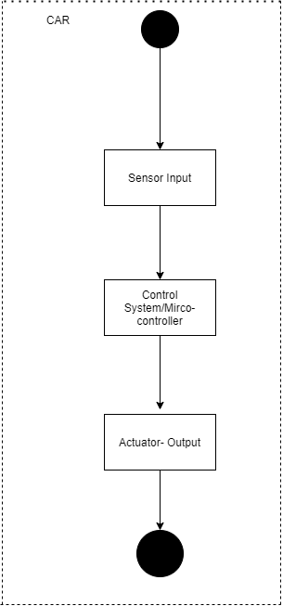

Figure 9.High-Level Design(Activity-Diagram) -Embedded C

#### Unit-Level Design (Low-Level Design)

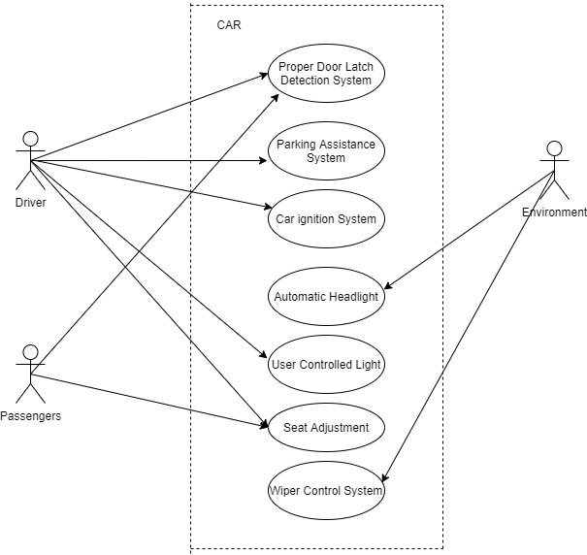

Figure 10.Low-Level Design (Use-Case Diagram) Embedded C

## Test Plan

#### High-Level Test Plan

|  |  |  |  |  |  |
| --- | --- | --- | --- | --- | --- |
| **Test ID** | **Description** | **Expected Input** | **Expected Output** | **Actual Out** | **Type of Test** |
| HLR_01 | Door is closed | Door is Latched properly | Warning Light inside doesn’t glow/stops flowing | Green LED stops glowing | Requirement based |
| HLR_02 | Object is detected behind the car | Object behind the car | Warning light starts glowing | Blue LED starts glowing | Requirement based |
| HLR_03 | When there is no light around the car | There is night time/ car enters a dark place | Headlight Starts glowing | Green LED starts glowing | Requirement based |
| HLR_04 | When car is ignited | Turn On car through ignition button | Car is ignited | Red LED starts glowing | Requirement based |
| HLR_05 | When you want to turn light inside the car | Press the button for light | Inside-Light turns on | RGB sensor starts glowing | Requirement based |
| HLR_06 | When rain starts | Rain/Water | Turns on Wiper | Blue LED starts glowing | Requirement based |
| HLR_07 | Seat is adjusted | Press button for seat adjustment once/twice for leaning | Seat starts leaning | Green LED glows then Red LED glows | Requirement based |

Table 7. High-Level Testing (Embedded C)

#### Low-Level Test Plan

|  |  |  |  |  |  |
| --- | --- | --- | --- | --- | --- |
| **Test ID** | **Description** | **Expected Input** | **Expected Output** | **Actual Out** | **Type of Test** |
| LLR_011 | Door is not properly closed | Path of LDR is not blocked | Light inside car will keep on glowing | GPIO pin PD12 is set | Requirement based |
| LLR_012 | Door is properly closed | Path of LDR is blocked | Light inside car stops glowing | GPIO pin PD12 is reset | Requirement based |
| LLR_021 | There is no object behind the car while parking. | No obstruction around PIR motion sensor | No Warning Light at the back of the car | GPIO pin PD15 is not set/reset | Requirement based |
| LLR_022 | When there is something behind the car while parking. | Obstruction around PIR motion sensor | Warning Light starts glowing at the back of the car. | GPIO pin PD15 is set | Requirement based |
| LLR_031 | When Light is there in surrounding | Light keeps falling on LDR sensor | Headlight doesn’t glow | GPIO pin PD12 is set | Requirement based |
| LLR_032 | When there is no light in the surrounding | Light stops falling on LDR sensor | Headlight starts glowing | GPIO pin PD12 is reset | Requirement based |
| LLR_041 | When car gets ignited | Press the blue button | Car started | GPIO pin PD14 is set | Requirement based |
| LLR_042 | When is turned off | Press the black button | Car stopped | GPIO pin PD14 is reset | Requirement based |
| LLR_051 | When you want to turn on light inside the car | Press the blue button | Light inside the car is turned on | RGB sensor light is set | Requirement based |
| LLR_052 | When you want to turn off light inside the car | Press the black button | Light inside the car is turned off | RGB sensor light is reset | Requirement based |
| LLR_061 | When there is no rain | No rain | Wiper will not move | GPIO pin PD15 is set | Requirement based |
| LLR_062 | When there is rain | Moisture or water on soil moisture sensor | Wiper will start moving automatically | GPIO pin PD15 is reset/not set | Requirement based |
| LLR_071 | Bending seat by 10% | Press the blue button once | Seat moves backwards by 10% | GPIO pin PD12 is set | Requirement based |
| LLR_072 | Bending seat by 20% | Press the blue button twice | Seat moves backwards by 20% | GPIO pin PD12, PD14 is set | Requirement based |
| LLR_073 | Seat comes to initial position | Press the blue button third time/ or don’t press the button even once | Seat moves to initial position | GPIO pin PD12, PD14 is reset/not set | Requirement based |

Table 8. Low -Level Testing (Embedded C)

## Implementation Summary

Multiple features of the car using STM32f407 discovery board has been implemented. Here we have assigned certain pins for GPIO input and output by board configuration in STM32CubeIDE. Then we have generated a high-level abstraction code and then we use certain GPIO HAL functions, ADC HAL functions and configured.

We have also used the same LED’s for different feature indications.

Also, GPIO Read and Write HAL functions are used very effectively based on the configured input and output pins.

Features implemented and pin configurations are as follows: -

1. Door Latch Detection System

PB7: Takes input from LDR

PD12: Denotes the door status (0: CLOSED PROPERLY, 1: NOT CLOSED PROPERLY)

1. Parking Assistance System:

PA4: PIR INPUT

PD15: OBJECT INDICATOR LIGHT (ON: IF OBJECT IS THERE, OFF: IF THERE IS NO OBJECT)

1. Automatic Headlight system:

PB9: Takes input from LDR

PD12: Headlight (on or off)

1. Car Ignition System:

PA0: Takes input from blue push button

PD14: Indicates Car is Turned On or Off

1. User controlled Light (Manual):

PA0: Act as an input (Blue push button)

PD15: Indicates Light inside the car

1. Wiper Control System:

PB6: Takes input from Soil Moisture Sensor

PD15: Indicates wiper turned On or Off

1. Seat Adjustment:

PA7: Input button (blue push button)

PD12: Seat tilts back by 10%

PD14: Seat tilts back by 20%

After this we have dumped codes in the STM32f407 discovery board and verified every feature that we have designed as a team.

## Individual Contribution & Highlights

#### Individual Contribution

My contribution here is that I have designed features for Door Latch Detection System and Parking Assistance System. Also, I have made connections for the same on the STM32f407 discovery board.

#### Highlights

Implemented hardware snippets: -

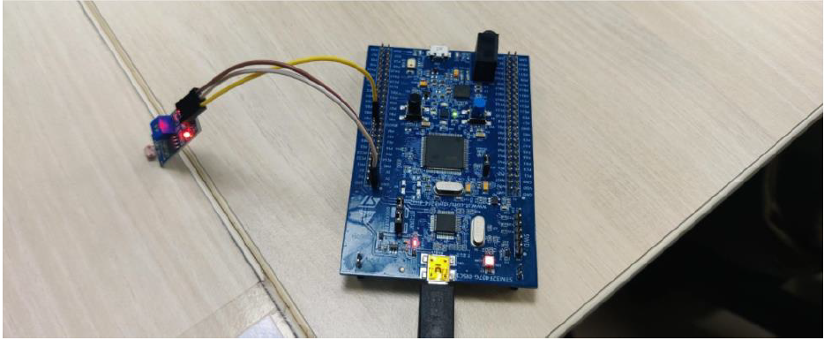

Figure 11.Implemented Circuit of Door Latch-Detection System

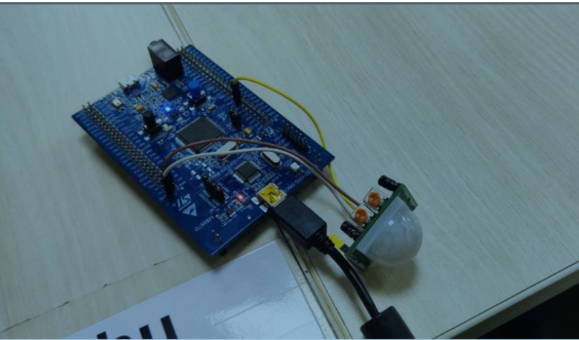

Figure 12.Implemented Circuit of Parking Assistance System

### Summary

In this project, we have used STM32f407 discovery board which has an ARM-microcontroller and a debugger embedded in it.

We have analyzed around 7 features that basically used in car and emulated as a demo over STM32board.

In this we have used various sensors such as soil moisture sensor (as a rain sensor), PIR motion sensor and LDR sensor according to their usage in the designed features.

Here we have dumped over Embedded C codes on the STM board and emulated the working of various designed features.

### Challenges faced and how were they overcome

* Issue’s with sensors-Resolved by replacing the sensors.
* Lose-wire connection – Debugging each port using OCD debugging.
* Incorrect output – Debugging port using OCD debugging.

# Miniproject -3 [Individual]

## Module

“Python”

### Topic and Subtopics

#### Core-Topics

* Basic Python

##### Sub-Topics

* Data Types
* Arithmetic operations
* String operations
* Control structures

##### Sub-Topics

* If-else statements
* While loops
* For loops
* Nested Loops
* Functions

##### Sub-Topics

* Defining custom functions
* Pass by value
* Pass by reference
* Introduction to Library functions
* Data Structures

##### Sub-Topics

* List
* Tuple
* Set
* Dictionary
* Exceptional Handling

##### Sub-Topics

* Try, Except
* Finally
* pass keyword
* Date and time Library

##### Sub-Topics

* Date comparison
* Execution time analysis
* Excel file library (openpyxl)

##### Sub-Topics

* Open multiple excel files
* Reading multiple excel files sheet by sheet.
* Mastersheet creation
* Writing to excel file

All these Core-topics and sub-topics are implemented through Agile-Methodology.

## Objectives & Requirements

#### Objective

To analyze data from multiple-excel spreadsheets of multiple Excel files stored over different directory and writing only the specific data on the Mastersheet or Master-workbook using Python Programming.

#### Requirements

##### High Level Requirements

|  |  |  |  |
| --- | --- | --- | --- |
| **ID** | **Requirements** | **Description** | **Status** |
| HLR01 | Multiple Excel Workbook | Multiple Workbook should be read over different directory | Implemented |
| HLR02 | Reading Worksheet | Reading multiple worksheet from multiple workbook | Implemented |
| HLR03 | Searching & Writing specific data | Searching in existing sheets and writing to Mastersheet or Master-workbook | Implemented |

Table 9.High-Level Requirements (Python)

##### Low-Level Requirements

|  |  |  |  |
| --- | --- | --- | --- |
| **ID** | **Requirements** | **Description** | **Status** |
| HLR01 - LR1 | Taking Multiple workbooks | Accessing multiple workbooks | Implemented |
| HLR01 - LR2 | Finding Path of file | Locating various Excel files based on filename from anywhere on the system and loading them | Implemented |
| HLR01 – LR3 | Excel file format | Excel file should be of .xlsx format | Implemented |
| HLR02 – LR1 | Data Collection | Data of share market for different shares collected in data different sheets of different workbook | Implemented |
| HLR02 – LR2 | Data size | Minimum number of rows=40, Minimum number of Columns=10 | Implemented |
| HLR03 – LR1 | Reading Data | Reading all multiple sheets from multiple workbook | Implemented |
| HLR03 - LR2 | Searching Data | Search for specific data based on user specific input | Implementing |
| HLR03 - LR3 | Writing only particular data | Writing data based on the searched data to Mastersheet or Master-workbook | Implemented |

Table 10.Low-Level Requirements (Python)

### Design

#### System Level Design

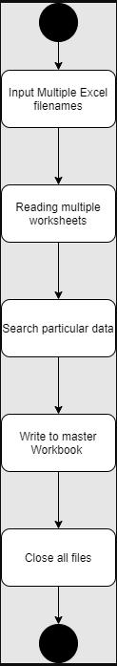

Figure .High-Level Design (Activity Diagram) Python

#### Unit Level Testing

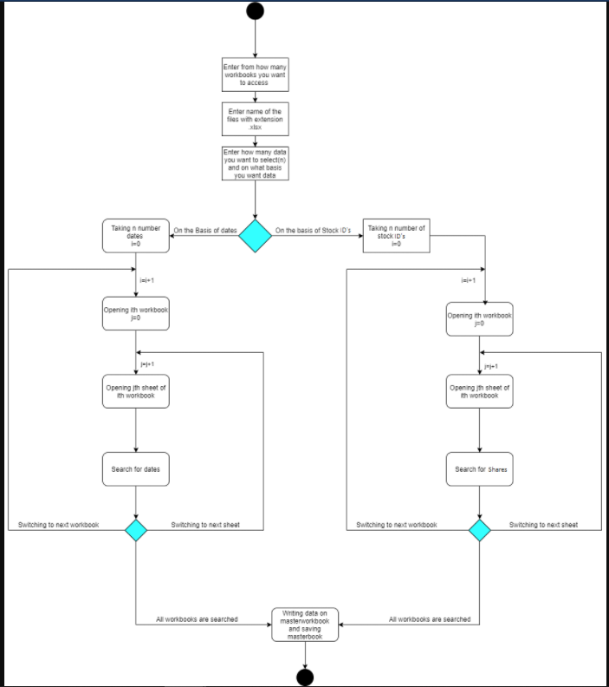

Figure 14. Low-Level Design (Activity Diagram) Python

### Test Plan

#### High level Testing

|  |  |  |  |  |  |
| --- | --- | --- | --- | --- | --- |
| **Test ID** | **Description** | **Expected Input** | **Expected Output** | **Actual Out** | **Type of Test** |
| HLR_01 | To Access multiple workbooks stored in different locations | Choice:2  Number of worksheets=2, C:\Users\99003731\Desktop\apps\New folder2\share_axis.xlsx  C:\New folder1\share_asian.xlsx | ‘<Workbook 1>’  ‘<Workbook 2>’ | ‘<Workbook1>’  ‘<Workbook2>’ | Requirement based |
| HLR_02 | To Read multiple worksheets of a workbook | Choice:2  Number of worksheet =1,  Enter file path: D:\New folder\share_adani.xlsx | ‘<ADANIPORTS>,  <Sheet 1>’ | ‘<ADANIPORTS>,  <Sheet 1>’ | Requirement based |
| HLR_03 | To Search by date | Choice:1 (to take excel files path from file)  Choice1 :1 (To search by date)  Number of dates:2  Date :2/2/200  Date: 3/1/2000 | All the Data of 2/2/2000 and 3/1/2000 copied to master-workbook | All the data of 2/2/2000 and 3/1/2000 copied to master-workbook | Requirement based |

Table 11.High-Level Testing (Python)

#### Low Level Testing

|  |  |  |  |  |  |
| --- | --- | --- | --- | --- | --- |
| **Test ID** | **Description** | **Expected Input** | **Expected Output** | **Actual Out** | **Type of Test** |
| HLR01-LR01 | To access multiple worksheets by provide their path one by one | Choice: 2  Number of worksheets = 3  Enter file path: C:\Users\99003731\Desktop\apps\New folder2\share_axis.xlsx  Enter File path:  C:\New folder1\share_asian.xlsx  Enter File path:  D:\New folder\share_adani.xlsx   |  | | --- | |  | | ‘<Workbook 1>’  ‘<Workbook 2>’  ‘<Workbook 3>’ | ‘<Workbook1>’  ‘<Workbook2>’  ‘<Workbook 3>’ | Requirement based |
| HLR01-LR02 | To access multiple worksheets whose paths are present in text file | Choice:1  File.txt | Starts reading every worksheet | Starts reading every worksheet | Scenario based |
| HLR02-LR01 | Searching data by only dates | Choice:1 (to take excel files path from file)  Choice1 :1 To search by date  Number of dates:2   1. 29/2/200 2. 31/1/2000 | All the Data of 29/2/2000 and 31/1/2000 copied to master-workbook | All the data of 29/2/2000 and 31/1/2000 copied to master-workbook | Requirement based |
| HLR02-LR02 | Search Data by only ShareID | Choice:1 (to take excel files path from file)  Choice1 :2 To search by ShareID  Number of shares:2   1. HD855 2. AP575 | All the Data related to ShareID’s HD855, AP575 is copied to master-workbook | All the Data related to ShareID’s HD855, AP575 is copied to master-workbook | Requirement based |
| HLR02-LR03 | Search data by both date and ShareID | Choice:1 (to take excel files path from file)  Choice1 :3 To search by both ShareID  Number of dates: 2   1. 4/2/2000 2. 17/1/2000   Number of shares:1   1. HD855 | All the data on 4/2/2000,  17/1/2000 for  ShareID HD855 is copied to master-workbook | All the data on 4/2/2000,  17/1/2000 for  ShareID HD855 is copied to master-workbook | Requirement based |
| HLR03-LR01 | To Skip date which is not present in the sheets and search for all the other data | Choice:1 (to take excel files path from file)  Choice1 :1 To search by date  Number of dates:2   1. 29/2/200 2. 26/1/2000 (Not a valid date) | Only data of 29/2/2000 copied to master-workbook | Only data of 29/2/2000 copied to master-workbook | Scenario based |
| HLR03-LR02 | To Skip ShareID which is not present in the sheets and search for all the other data | Choice:1 (to take excel files path from file)  Choice1 :2 To search by ShareID  Number of shares:2   1. AX700 (Invalid ShareID) 2. AP575 | Only data of AP575 copied to master-workbook | Only data of AP575 copied to master-workbook | Scenario based |
| HLR02-LR03 | To Skip date/ShareID which is not present in the sheets and search for all the other data | Choice:1 (to take excel files path from file)  Choice1 :3 To search by both ShareID  Number of dates: 2   1. 4/2/2000 2. 17/1/2000   Number of shares:1   1. AB878 | Empty Master-workbook | Empty Master-workbook | Scenario based |

Table 12.Low-Level Testing (Python)

## Implementation Summary

Here I have programmed in such a way that the code is able to read various excel files stored in different locations and extract only particular data from the excel files based on date and ShareID and display it on a separate excel file called masterbook.

All the source files are present in /3_Implementation/src folder

Here I have divide the code into multiple files where the modules related for multiple input’s and their validation in the given excel files are taken care. Also, there is separate module file to access excel files from various location which has two ways to access the excel file first by accessing file where path of excel file is already stored and secondly by accessing the file where user provide their paths one by one.

Also, exceptions are used to avoid traceback at certain places and situations.

Follow these steps to execute the code: -

* To Run the code run->main.py file (present in Implementation/src folder)
* Enter -1 If you want to open workbooks present in file"

(for path through file you have all share datasets in the folder named data inside src folder copy those .xlsx file various directory and copy the path in file.txt)

* Enter -2 If you want to enter location and open workbooks

(Here also copy all data files from data folder in src.)

Then enter 3 cases by which means you want search or filter data

* Enter -1 To search data by Dates
* Enter -2 To search data by ShareID
* Enter -3 To search data by both Dates and ShareID
* Then enter number of dates or shares you want and then enter dates or shares one by one
* At the end, all data will be printed on masterbook.xlsx file present in src folder

Predefined python module libraries used: -

1. openpyxl
2. time

Mandatory: To add the GitHub user - **stepin654321** as a contributor to the repo”

### Video Summary

“Please upload a short video on the repo for the walkthrough of the project (Team/Individual) less than 7min and less than 30MB File Size. Start is the Standard opening slide with title of Miniproject + Team members followed by the walkthrough ”

### Git Link

<https://github.com/99003731/Python_Mini_Project.git>

### Git Dashboard

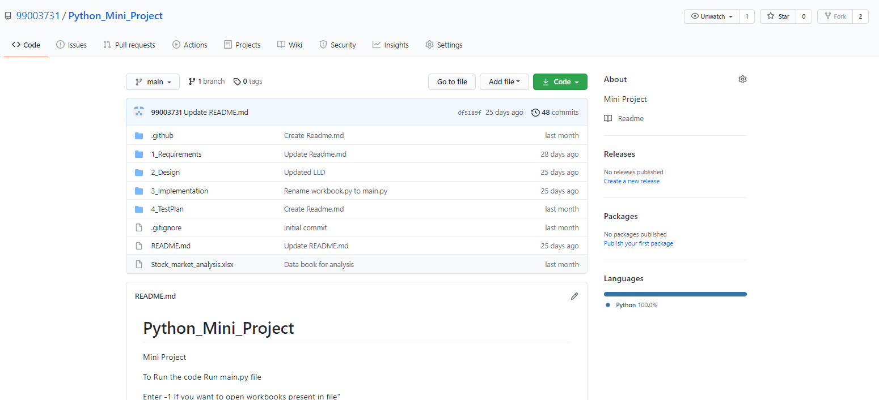

### Summary

In this project, I have worked on data of 5 different shares stored in 5 different excel files which stored in different directories in all over the PC. The share data in excel file is from Jan-2000 to Feb-2000.

Here, first every workbook is opened as soon as their paths were provided (5 different pointer stores base address of every workbook). Then when we enter the criteria through which we want to segregate the data and populate it over the masterbook.

After this code searches for the data, sheet by sheet and data related to that criteria (date, ShareID) in all the sheets gets populated to the masterbook.

Also, the data here is searches in each cell of the excel sheet and copy the data cell by cell to the masterbook

### Challenges faced and how were they overcome

* Accessing excel file from different location and automating it for multiple sheets – This issue was overcome by using nested loops and using openpyxl module load_workbook method.
* Searching common data by two unique data’s simultaneously - This was again solved by analyzing flow of multiple loops using exceptions at right place.

### Future Scope

* Searching in huge amount of data needed to be analyzed.
* Graphs of the extracted data can be analyzed for better analyses.
* Code can be more optimized and automatic generation of Mastersheet or masterbook can be added.
* This code as an API or GUI can be used in analysis of data in share market by plotting scatter plots and histograms.

# Miniproject -4 [Individual]

## Module

“Kernel and Device Drivers”

### Topic and Subtopics

#### Core-Topics

* System Calls

##### Sub-Topics

* C programming
* Custom Kernel Image Generation
* Cross-Compilation (using Qemu)
* IPC (Inter- Process Communication)

##### Sub-Topics

* C programming
* Process
* Race Condition
* Semaphores
* Mutex
* Spinlock
* Wait Queue
* Threads
* Custom Modules

##### Sub-Topics

* Kfifo API
* List API
* Module development
* IOCTL

## Objectives & Requirements

“High level and low level in the template ”

## Design

“System Level and subsystem level UMLs – Structural and Behavioral”

## Test Plan

“Integration level and unit level in the template”

## Implementation Summary

“Section focused toward’ s implementation aspects. Here it is only core summary while all the details are in the Git Repo

Note: The GitHub private repo should be documented (Readme.md files at each folder level)

Ensure code quality and clean code and description practices

Mandatory: To add the GitHub user - **stepin654321** as a contributor to the repo”

### Video Summary

“Please upload a short video on the repo for the walkthrough of the project (Team/Individual) less than 7min and less than 30MB File Size. Start is the Standard opening slide with title of miniproject + Team members followed by the walkthrough ”

### Git Link

“Link to the repo”

### Git Dashboard

“Screenshot of the GitHub Repo page with all the badges and summary”

### Summary

“Brief summary on the overall implementation”

#### Git inspector summary

“In linux install gitinspector and Run the command –

gitinspector -H -l -m -T -w -r --grading --format=html > gitinsp.html

and upload the same to your repo and paste the snapshot in the report”

#### Build

“Brief on outcome of the build and setup done”

#### Code quality and Issues or Bug Tracking

“Brief on code quality, errors and warnings flagged (issues created) and fixed ”

#### Unit Testing

“Unit Testing setup alignment with test plans and summary of outcome”

## Individual Contribution & Highlights

“Brief on Contributions by you for Team”

### Summary

“Key Highlights not covered till now, Softskills and technical side”

### Challenges faced and how were they overcome

“Brief and crisp”

### Future Scope (If applicable)

### 